JS engine main task is to read and execute. Call stack and memory heap play the important parts here

Call stack help to keep track where we are in the code and its execution

Memory Heap as a place to store and write information, allocate memory, use memory and release memory

Stack overflow is easy from recursion function. Example, function that call itself

JS is a garbage collected language, when JS allocate memory automatically when we finish calling function and we don’t need that allocation anymore, it will clean it up. Only data that still useful to use will remain. This to prevent memory leaks (overflow of memory), JS can freeze the memory.

But this doesn’t mean we shouldn’t care about memory management. Low level language like C give you control in removing memory.

Garbage collection use algorithms called Mark and Sweep

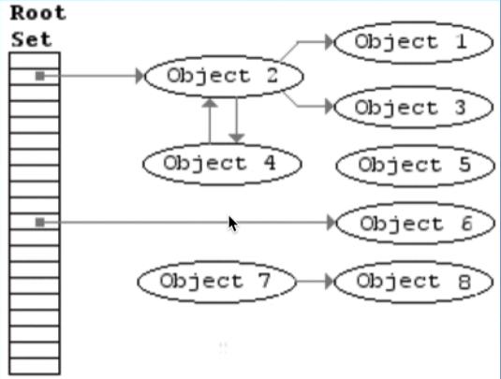

Memory leak can demo by using infinite loop with array pushing